EXCEL SKILLS: INTERMEDIATE

* When we have multiple sheets that are similar in format and we want to change a certain name of certain cell in all the sheets simultaneously, we can CTRL+SELECT all the similar workbooks and then make changes to a cell. This will be copied to all the worksheets.

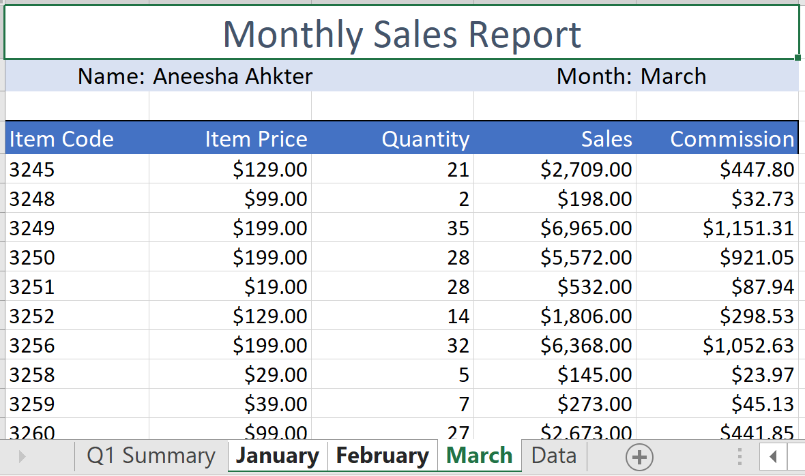

* 3D Formulas: Adding across sheets can be done in a variety of ways

1. Go to individual sheets and select the cell number to add as shown below

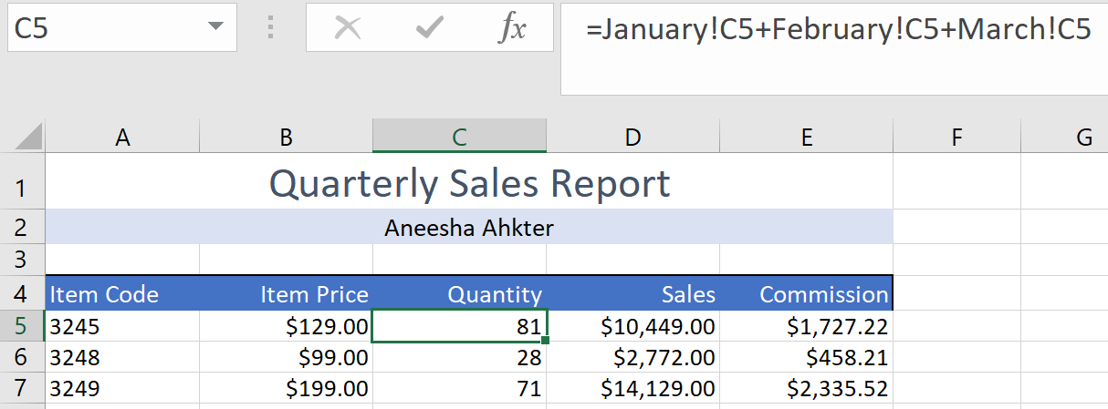

1. The other way to do this is to use SUM function across the sheets. In the main sheet where we need the sum, type =SUM( and select the first cell of the sheet to be added and click SHIFT and go the last sheet and select the cell and type ) and ENTER. (NOTE: All the sheets of interest need to be ordered in the bottom and moving the sheets around can cause the formula to BREAK)

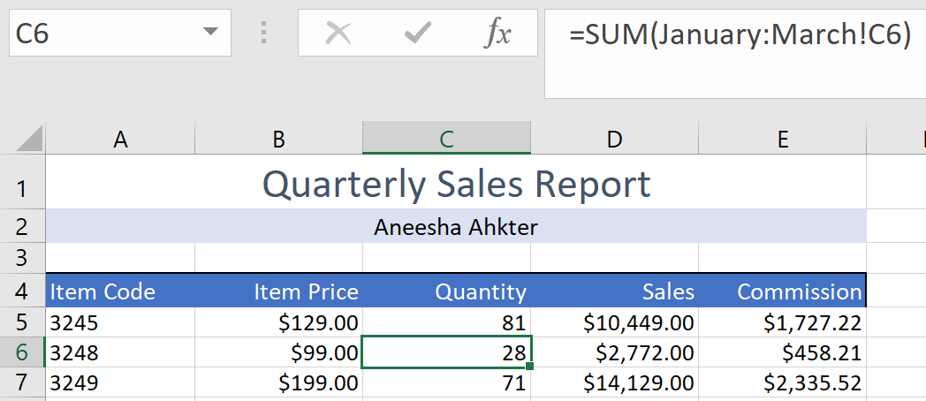

* When we have similar kind of multiple sheets (non similar too) we want to work with, there is a helpful tool to arrange all the workbooks across the screen for ease of work as shown below that arranges all the workbooks. (Select TILED option)

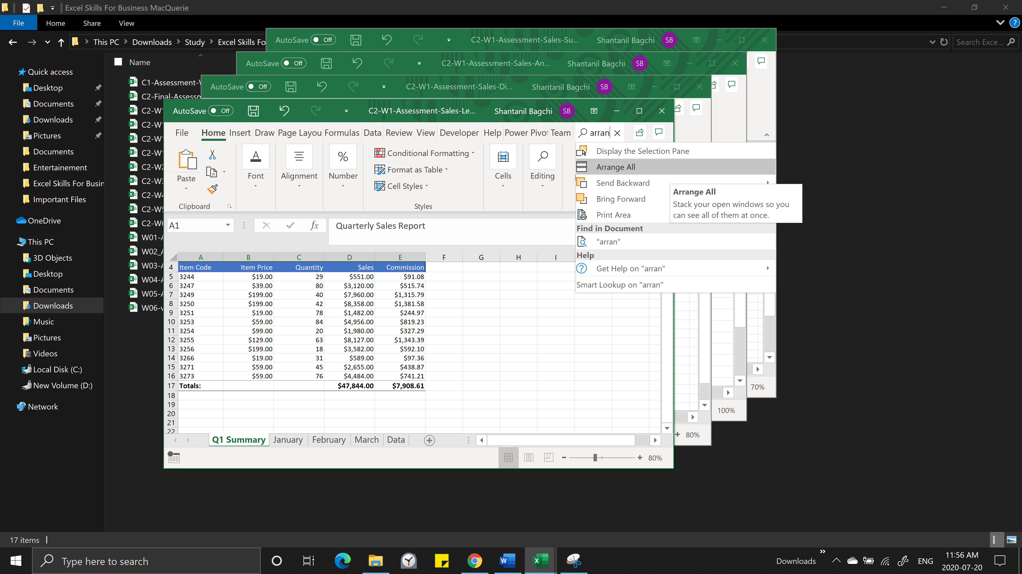

* When we have connections to different workbooks in a single file, changing the name of any of the linked workbook will result in LINK BREAK in the main file. In order to correct it, we can select the option as shown .

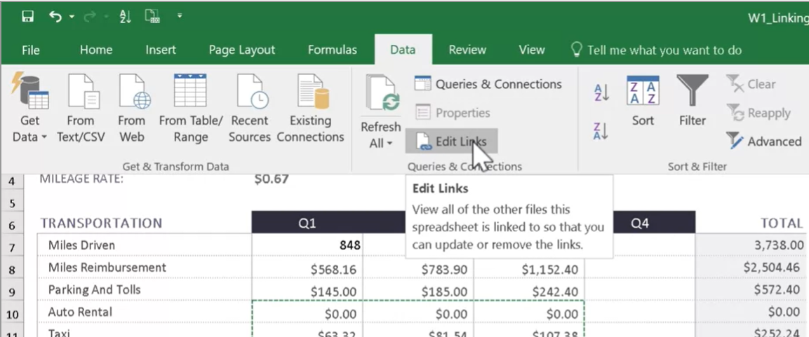

Once the following DIALOG BOX opens, we can see the status of the links used. If any workbook name is changes, we can click on the CHANGE SOURCE options shown and select the renamed file.

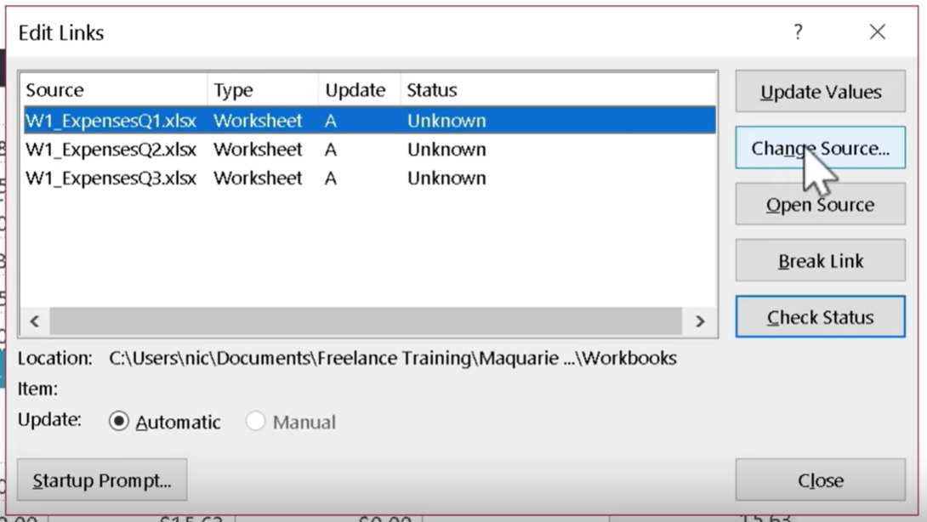

* DIFFERENT WAY TO LINK WORKBOOKS (Consolidate Data)

1. A quick way to link all the similar format workbooks is to use consolidate data option as shown below.

There are a lot of options provided to take advantage of.

1. We can select custom function provided to populate our sheets.
2. We need to select the data ranges in any worksheets and select ADD option to include it in our reference list before selecting the next data range.
3. Consolidating the Data creates values only at that time instant i.e. it is not linked to change in data. If any data changes and we need to update the summary sheet, we need to open consolidate data again and just click okay to update the values.
4. The other way to avoid this will be to click on ‘Create links to source data’ at the bottom but it should only be used when we are sure as this creates additional rows and links which can be cumbersome to remove later in case we want to change the formatting.

(NOTE: This only works when all the data have similar row and/or column name. In case there are different names in row or column, we can consolidate by clicking the TOP ROW or LEFT COLUMN option to consolidate the data which is similar to LEFT JOIN function)

